TIPS FOR LOCALIZING
***FOR MARKETS: Consider selecting additional destinations and accommodations based on desk research on bike-friendly stays with bicycle rental service to ensure the pitch is relevant for your market. For relevant data, please check the All Survey Document on Box and request it via the Hub.

The following Booking.com business priorities are reflected in this pitch:
- Connected Trip (attractions)
- US

When creating a local pitch, please keep this in mind and make sure your content is tied to certain Booking.com business priorities as well as your market-specific KPIs.

Please also check that attractions are still available to book within the 90-day period.

As always, please share content with your day-to-day Booking.com contact for final approval***

Booking.com Shares Five Stays to Get on a Bike And Celebrate World Bicycle Day

Celebrated annually on June 3, World Bicycle Day advocates the benefits of cycling and promotes this environmentally friendly and sustainable means of transportation. According to Booking.com research, more than half (54%)* of global travelers intend to use more sustainable modes of transport while traveling in 2024 and two-fifths (41%)* is planning their trip specifically so they can walk or bike. With a mission to make it easier for everyone to experience the world, Booking.com presents five places to stay to celebrate this day in a both fun and impactful way.

Flandrien Hotel, Brakel, Belgium
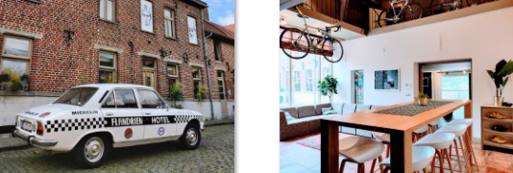
Flandrien Hotel is a great place for both bike lovers and cycling teams. The property offers a variety of race bikes and helmets to rent as well as navigation bike computers pre-installed with popular routes of the surrounding region. Guests can spend some time at the hotel’s photo exhibition by a popular cycling photographer or check its Pop-Art collection celebrating the lives of Flemish and international cycling legends. Highly endorsed for cycling, countryside and walking, Brakel is located in the Flemish region of Belgium. The vibrant city of Ghent is a two hour bike ride away and guests can enjoy a variety of activities there like a guided biking tour to explore Ghent's iconic sights or even a guided tour with an offroad E-Scooter if wanting to give tired legs a rest from pedaling.

Hotel Crillon le Brave, Crillon-le-Brave, France
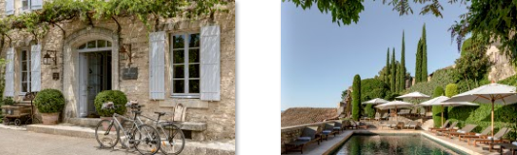
Located in the Vaucluse department in the Provence-Alpes-Côte d'Azur region of Southeastern France, Hotel Crillon le Brave is an elegant property surrounded by beautiful vineyards and olive trees. Characterized by traditional stone houses and cobbled streets, the hilltop village of Crillon le Brave offers stunning views of the surrounding Provencal landscape and Mont Ventoux. Highly endorsed for cycling, scenery and nature walks, Crillon-le-Brave is a great base to plan a day out with bicycles. Guests can rent a bike and cycle along the vineyards and lavender fields, taking place from mid-June to the end of July. The picturesque city of Avignon is a leisurely two hour bike ride away and there travelers can enjoy a variety of outdoor activities like a guided bus tour to the lavender fields or a guided walk through Avignon's medieval center.

Willows Lodge, Woodinville, United States of America
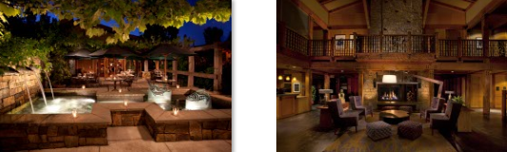
Whether alone or with friends, one of the best ways to celebrate World Bicycle Day is by simply going for a bike ride. Nestled in the picturesque town of Woodinville, in Washington state, Willows Lodge is great for cycling enthusiasts who need a base for their rides to scenic trails and winery tours. Guests can borrow a bike from the hotel and explore the Sammamish River Trail, a 10 mile (16 km) bike path and recreational rail trail, perfect for those looking for a relaxing ride in Woodinville. The city hosts various cycling events and races throughout the year, where travelers can ride, socialize and enjoy the views. After a busy day cycling in the great outdoors, guests can relax at the lodge’s spa area and enjoy spa treatments as well as refreshing face and body therapies.

Trail's End, Elgin, South Africa
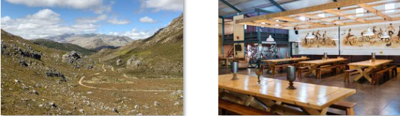
Set in the foothills of the Elgin Valley, Trail's End Bike Hotel provides easy access to some of South Africa’s most popular biking trails for all levels. Guests can use the hotel’s bike rental service, while those traveling with their own bike can take advantage of the secure storage space or make any necessary repairs at the onsite bike store and repair shop. Highly endorsed for relaxation and countryside, the lush area of Elgin is about 40 miles (64 km) southeast of Cape Town and is surrounded by imposing mountains and numerous scenic trails. Travelers who want to spend the day in Cape Town can choose from a variety of activities like booking an audio-guided walking route along the scenic, oceanfront walkway or a water bike tour off the coast of nearby Simon’s Town.

Ulaman Eco Luxury Resort, Tabanan, Indonesia
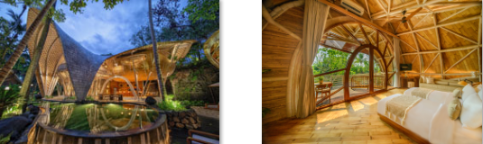
Offering free bikes, Ulaman Eco Luxury Resort is an adults-only villa complex, perfect for those looking for a secluded stay to rechange. Set within a lush tropical forest, this unique stay is home to a lake, a twin waterfall and a river that runs through its premise. Highly endorsed for nature and countryside, the town of Tabanan in Central Bali is home to beautiful temples as well as scenic bike routes through expansive rice paddies. Travelers can cycle through the traditional villages of the surrounding area and learn about the Balinese culture by interacting with the locals. The city of Ubud is about 28 miles (45 km) away, and travelers can choose from a variety of outdoor activities like a private guided tour at Sumampan waterfall or a private day tour with a local.

*Research commissioned by Booking.com and independently conducted among a sample of 31,550 respondents across 34 countries and territories (1,000 from USA, 1,000 from Canada, 1,000 from Mexico, 1,000 from Colombia, 1,000 from Brazil, 1,000 from Argentina, 1,000 from Australia, 500 from New Zealand, 1,000 from Spain, 1,000 from Italy, 1,000 from France, 500 from Switzerland, 1,000 from the UK, 1,000 from Ireland, 1,000 from Germany, 1,000 from the Netherlands, 1,000 from Belgium, 1,000 from Denmark, 1,000 from Sweden, 950 from Croatia, 500 from UAE, 1,000 from India, 1,000 from China, 800 from Hong Kong, 1,000 from Thailand, 1,000 from Singapore, 1,000 from Taiwan, 1,000 from Vietnam, 1,000 from Indonesia, 1,000 from Philippines, 1,000 from South Korea, 1,000 from Japan, 1,000 from South Africa and 300 from Kenya ). In order to participate in this survey, respondents had to be 18 years of age or older, had to have traveled at least once in the past 12 months and must be planning to travel in 2024, and be either the primary decision maker or involved in the decision making of their travel. The survey was taken online and took place in February 2024.

**Research was commissioned by Booking.com and independently conducted among a sample of adults who took a leisure trip with an overnight stay in the last 12 months, plan to travel in 2024, and are involved in trip planning. The sample comprises of 32,300 respondents across 32 markets surveyed in January or February 2024. (2,000 from USA, 800 from Canada, 1,800 from Mexico, 800 from Colombia, 1,800 from Brazil, 800 from Argentina, 1,800 from Australia, 500 from New Zealand, 800 from Spain, 800 from Italy, 1,800 from France, 1,800 from UK, 1,800 from Germany, 800 from Netherlands, 500 from Denmark, 500 from Sweden, 400 from Croatia, 800 from Switzerland, 800 from Belgium, 800 from Ireland, 800 from Portugal, 1,800 from India, 800 from China, 500 from Hong Kong, 800 from Thailand, 800 from Singapore, 500 from Taiwan, 800 from Vietnam, 800 from South Korea, 1,800 from Japan, 500 from UAE).

